

UNIVERSITY OF BAMENDA

HIGHER TEACHER TRAINING COLLEGE (HTTC)

BAMBILI-BAMENDA

******************

P.O. BOX 39, BAMBILI

UNIVERSITY DE BAMENDA

ECOLE NORMALE SUPERIEURE

(ENS)

BAMBILI-BAMENDA

******************

P.O. BOX 39, BAMBILI

**DEPARTMENT: COMPUTER SCIENCE**

LEVEL: **400 (Year 3)**

**AN INTELLIGENT CROSS-PLATFORM SOFTWARE THAT CONNECTS CAMEROONIAN FARMERS WITH AGRICULTURAL STAKEHOLDERS**

*A Dissertation submitted to the Department of Computer Science of the Higher Teacher Training College in partial fulfillment of the requirements for the award of an Under Graduate Diploma (DIPES 1) in Computer Science*

Presented by:

**BOUJIQUE LAH EVARISTE JOEL (UBa18G0077)**

**&**

**FON ANSELM CHE (UBa18G0082)**

**SUPERVISOR**

**Mme NDOFOR MARIETTE**

**May 2021**

© Copyright, 2021

All Rights Reserved

# DECLARATION

We, **BOUJIQUE LAH EVARISTE JOEL** and **FON ANSELM CHE** registration No **UBa18G0077** and **UBa18G0082** respectively, of the Department of **Computer Science** of the Higher Teacher Training College (H.T.T.C.) of the University of Bamenda hereby declare that, this work entitled: “**A WEB-BASED PLATFORM TO CONNECT CAMEROONIAN FARMERS WITH AGRICULTURAL STAKEHOLDERS**" has been done by us. It has not been presented in any application for a degree or any academic pursuit. We have sincerely acknowledged all borrowed ideas nationally and internationally through citations.

**FON ANSELM CHE**

Date:

Signature:

**BOUJIQUE LAH EVARISTE JOEL**

Date:

Signature:

# CERTIFICATION

This is to certify that this research entitled: " **A WEB-BASED PLATFORM TO CONNECT CAMEROONIAN FARMERS WITH AGRICULTURAL STAKEHOLDERS**” is the original work of BOUJIQUE LAH EVARISTE JOEL and FON ANSELM CHE. This work is submitted in partial fulfilment of the requirements for the award of an Under Graduate Diploma (DIPES I) in COMPUTER SCIENCE (CSC), Higher Teacher Training College (H.T.T.C.) of the University of Bamenda, Cameroon

**Mme Ndofor Mariette**

**(Supervisor)**

**Mme Ndofor Mariette**

(Head of Department)

Having met the stipulated requirements, the dissertation has been accepted by the Postgraduate School.

Date:

The General Coordinator

Postgraduate School

# DEDICATION

**This piece of work is dedicated**

**To**

**Our Parents**

# ACKNOWLEDGEMENTS

* We begin by thanking the Almighty God who gave us the inspiration, motivation, strength and especially the courage to carry out this work.
* Our special thanks goes to my supervisor **Mme Ndofor Mariette**, for her guidance and support throughout the whole project.

We also thank:

* The Vice Chancellor of the University of Bamenda Prof. Theresia Nkuo-Akenji
* The Director of HTTC Bambili Prof. Tita Margaret
* The HOD of computer science department a mother indeed
* To our entire families, for their continuous encouragement and diverse support.
* Finally, thanks to all my friends and classmate for their moral support.

# ABSTRACT

The business of agriculture is a lucrative one. But like every other business, it requires Capital/investment. In Cameroon, like in many other developing countries, accessing financing is a real headache for farmers. Individuals of other professions however have fewer difficulties in obtaining credit from financial institutions. So on one hand, we have farmers struggling to find investment for their farm projects, and on the other, individuals who are capable of investing money in agriculture. The aim of this project is to develop a mobile platform to connect farmers with lucrative farm projects, to investors (stakeholders). The platform basically puts farmers, and all other actors of the agricultural sector together, for the purpose of helping farmers raise funds for their projects. The platform supports two types of users; farmers, and investors (stakeholders). Registered Farmers are allowed to register their projects by providing all relevant details including images, videos and documentation. These farm projects are intelligently recommended to the registered investors, through a well-designed content feed. Investors can contact the farmers involved in projects that call their attention, by sending auto-generated emails to these farmers. The platform is built principally on the JavaScript framework: React JS, for frontend purposes. While the backend of the project is built with the PhP framework Laravel. These web technologies are put together to develop a mobile responsive, web based application which is extremely easy even for less educated farmers to use. Farmers can access the platform from anywhere, to connect their projects to potential investors.

# TABLE OF CONTENTS

DECLARATION ii

CERTIFICATION iii

DEDICATION iv

ACKNOWLEDGEMENTS v

ABSTRACT vi

Table of Contents vii

LIST OF TABLES ix

LIST OF FIGURES x

LIST OF ABBREVIATIONS xi

CHAPTER 1: GENERAL INTRODUCTION 1

1.1 Background 1

1.2. Problem Statement 3

1.3. Objectives of the Project 4

1.3.1 General Objective 4

1.3.2. Specific Objectives 4

1.4 Research Questions 4

1.5 Scope of Study 5

1.6. Limitations 5

CHAPTER 2: LITERATURE REVIEW 7

Introduction 7

II.1.The Digital Agriculture Revolution 7

II.1.1. The Use of Mobile Technology in Agriculture 8

II.2. Financial Technology (FinTech) 9

II.3. Crowd Funding in Cameroon 9

CHAPTER 3: METHODOLOGY 12

Introduction 12

III.1 Requirements 12

III.1.1 Methods used to achieve the aims of the project 12

III.1.2. Hardware and Software requirements 18

III.2.1 Justification for the choice of modeling language – UML 20

III.2.2. Description of the System 20

III.3. Implementation 22

III.3.1 Class diagram 22

III.3.2 Activity Diagram 23

III.3.4. Use Case diagram (UML) of FaShCoP 24

CHAPTER 4: RESULTS AND DISCUSSION 25

IV.1 Summary of Results 25

IV.1.1. Testing 25

IV.1.2 Project Assessment 25

CHAPTER 5: GENERAL CONCLUSION 34

V.1 Reflection 34

V.2. Recommendation for Future Development 35

References 37

# LIST OF TABLES

Table 1: Advantages and disadvantages of the Waterfall Model 15

Table 2: Advantages and disadvantages of the Prototyping model 17

# LIST OF FIGURES

Figure 1: System Development Life Cycle 13

Figure 2: The Waterfall Model 14

Figure 3: The Prototyping Model 16

Figure 4: Class diagram FaShCoP 22

Figure 5: Activity Diagram 23

# LIST OF ABBREVIATIONS

|  |  |
| --- | --- |
| ABBREVIATIONS | MEANING |
| FASHCOP | Farmer Stakeholder Connect Platform |
| FINTECH | Financial Technology |
| SDLC | System Development Life Cycle |
| UML | Unified Modelling Language |
| NGO | Non-Governmental Organization |

# CHAPTER 1: GENERAL INTRODUCTION

## Introduction

Agriculture is a lucrative business in Cameroon. The fertile soils, favourable climates, appropriate topographies and available water supplies are lined up in favour of massive productivity. This sector of the economy is capable of providing employment to millions of young Cameroonians. However, the business of agriculture like every other business, requires Capital/investment. In Cameroon, like in many other countries in Africa, accessing financing is a real headache for farmers. Official studies have found that individuals, however, have fewer difficulties in obtaining credit from financial institutions. In the second half of 2019, individuals captured 18% of loans granted by banks within the CEMAC region according to a report by the Bank of Central African States (BEAC). For this reason, individuals and even NGOs with access to financing, are seeking to invest their money and expertise in the agricultural sector, with the aim of making profit. Several startups by young Cameroonians are attempting to solve this major paradox, with the use of financial technology such as crowdfunding. While start-ups cannot construct roads or build markets, they can leverage digital technology to create virtual markets, disease detection systems, or crowd funding platforms, etc. that could provide invaluable help to these farmers. A farmer stake-holder connect platform is an excellent means to connect farmers with farm projects, to stakeholders (private investors, NGOs, agro technicians) willing to invest in the agricultural sector. This will allow genuine farmers to expose their projects to potential funding and mentorship opportunities. This study proposes an intelligent cross platform software which will help investors identify and invest in profitable farm projects, while farmers will benefit from funding offered by these investors (stakeholders). This is in order to support agriculture’s sustainability. The model connects all actors (farmers, landowners, investors, and consumers) into a platform that can promote transparency, empowerment, resourcefulness, and public engagement in agriculture.

## Background of the study

Agriculture remains the backbone of Cameroon's economy, employing 70 percent of its workforce, while providing 42 percent of its GDP and 30 percent of its export revenue. Blessed with fertile land and regularly abundant rainfall in most regions, Cameroon produces a variety of agricultural commodities both for export and for domestic consumption. Coffee and cocoa are grown in central and southern regions, bananas in southwestern areas, and cotton in several Northern Regions. In addition to export commodities, Cameroonian farmers produce numerous subsistence crops for family consumption. Principal food crops include millet, sorghum, peanuts, plantains, sweet potatoes, and manioc. Animal husbandry is practiced throughout the country and is particularly important in northern Regions. The lack of access to adequate amounts of safe and nutritious food is a public health concern worldwide and particularly in Cameroon. Due to its agro-ecological diversity, Cameroon has great potential for agricultural production to contribute towards its over 26 million people and beyond, thus contributing towards feeding the world’s 9 billion people.

Many young Cameroonians are leveraging technology to provide solutions to some of the problems facing agriculture in Cameroon. Several agro start-ups have emerged, based on digital technologies that solve problems such as; access to markets, access to financing, crop monitoring and disease, etc. Some of the digital solutions to the challenges of the agro-sector include;

Agrix-Tech is a Yaoundé-based start-up that has launched an artificial intelligence-based platform to help African farmers tackle crop pests and plant diseases from their source. The technology helps detect plant diseases and offers both chemical and physical treatment as well as prevention measures.

Save Our Agriculture is another Cameroonian start-up which specializes in Aquaponics, a field of modern agriculture that produces vegetables and fish without chemical fertilizers. In addition to the production of vegetables and fish without chemical fertilizers, the Cameroonian start-up created in 2015, also designs aquaponics kits for home aquaponics.

Agro-hub is one more start-up from Cameroon that makes innovative use of web and mobile technology, to alleviate farmers of their daily pain. The start-up works to provide these farmers with a much needed community, along with markets to sell their products. The start-up equally sources agricultural products directly from farmers and sells them directly to the general public.

## Problem Statement

Though blessed with fertile soil and regular rainfall in most parts, Cameroon’s agricultural output is still far below demand. This under-productivity costs the State treasury over 500 billion CFAF on food importation in 2010. In the traditional business process, farmers, especially in developing countries like Cameroon, suffer problems of funding deficiencies, capital issues, and limited access to financial institutions. Farmers need money from investors to rent land, buy seeds, fertilizers and any other supporting tools. Limited access to capital is a common problem among Cameroonian farmers. Many of them are declared “unbanked” by banking institutions, and often struggle to secure loans from financial institutions when trying to expand crop production. Funding however, is crucial in increasing farm productivity and output, which is key to the growth of the agro-sector of Cameroon’s economy.

This much solicited financing can come from several avenues, including; private investors (Home and abroad, locals and Internationals), Non-Governmental Organizations (NGOs), and even the Government. Official studies have found that individuals of other professions have fewer difficulties in obtaining credit from financial institutions. A good majority of Cameroonians are enthusiastic about investing in agriculture, but many do not want to get their hands dirty by going into the farms to carryout production themselves. This leaves us with individuals in the country looking to invest in sectors like agriculture, but face the difficulty of finding appropriate farm projects to invest in. Also, there are many agricultural NGOs in the country, seeking to support famers. Nevertheless, these organizations face the trouble of finding and reaching all needy farmers with ease. This implies that a good number of farmers are not able to get access even to the funding that is already made available to them. While farmers struggle to find financing to expand their farm projects, individual, NGOs and other agricultural stakeholders face the difficulty of locating and investing in these farmers and their projects.

## Objectives of the Project

### General Objective

Our objective is to design and prototype a software that will connect farmers with productive farm projects, to agricultural stakeholders (potential private investors, NGOs, and agro technicians). This prototype will take the shape of a cross-platform application, which will allow farmers to create accounts with complete personal profiles, and register their projects. These projects will be recommended to registered stakeholders, via a customized feed. Stakeholders can thoroughly investigate the submitted farm projects, and can reach out to farmers by contacting the farmers.

### Specific Objectives

We have the following specific objectives;

* Build a software that is accessible to everyone, both on mobile and on Personal Computers (PCs).
* A platform which is fast, lightweight, secure and responsive for the convenience of all potential users.
* The web application that is very user friendly and easy-to-use. Given the possibility of a high rate of computer illiteracy amongst most Cameroonian farmers.
* Design a user feed, which implements an algorithm that will carefully and automatically suggest registered farm projects to potential investors, depending on the location and preferences of the stakeholders.
* Design a chat forum, for investors to reach out to farmers with projects of interest.

## Research Questions

Research questions are the central question of the study that have to be answered on the basis of the research findings. The following research questions guided us through our project development;

* What are the most suitable digital technologies to develop and deploy a platform to connect farmers to investors?
* What are the basic functionalities that such a platform should have, to be able to meet farmer and investor needs?
* How exactly will farmers and investors use and benefit from this platform?

## Significance of the study

This study is important to all agricultural stockholders as it aims to link farmers who are looking to expand but lacks the funds and technical resources to potential investors (microfinances, technicians/engineers, Government institutions, private individuals), from the very comfort of their homes.

Also consider an individual/NGO or microfinance within or outside of the country, looking to invest in agriculture. FaSHCoP recommends registered projects, with the help of our machine learning model (Artificial intelligence) which recommends similar projects based on the ones they previously liked.

## Scope of Study

Lack of funding is an entire African agricultural pandemic. However, the scope of this project is limited to designing and prototyping a platform only for Cameroonian farmers, but available to both national and international stakeholders. The platform will allow farmers to register their farm projects. These projects will be intelligently recommended to investors (stakeholders) through a content feed. Investors can add projects to wish lists, contact farmers to receive more inquiries.

## Layout of Chapters

The following is how this project report has been organized. The project report is arranged into chapters, with each chapter addressing a different part in the project.

**Chapter 1 Summary:** Includes the introduction of the research in which it stated the purpose of this study and the objectives.

**Chapter 2 Summary:** This chapter addresses the literature review of the project. The review will discuss how farmers get capital to fund their projects.

**Chapter 3 Summary:** This chapter will outline the methods that were used to design and develop the farmer stakeholder connect system. This chapter will also discuss how the project activities as well as the project deliverables (what we expect as the output of each objective) was handled. Then in this chapter, the methodology that was used to develop this particular system has been clearly stated.

**Chapter 4 Summary:** This chapter talks about the research result.

**Chapter 5 Summary:** This chapter will focus on the conclusion and future works that will be done on the System.

## Summary

This chapter has provided a background to the study and has as well justified the importance for undertaking this study not only to the institution mentioned in the scope but to others as well. The aim of this study has been presented in this chapter including well defined objectives. This chapter has also given the organization of the study.

## 1.6. Limitations

No system exists without limitations. Though we were able to develop a fully working prototype of the farmer-stakeholder connect platform, the application still has some limitations;

* The farmer-stakeholder prototype which we developed has security limitations. The system is unable to detect suspicious activity, or fake user accounts (fake farmers or stakeholders). A standard machine learning algorithm is required to accomplish this.
* Based on the prototype we developed, the platform is limited only to connecting farmers to potential investors, agro technicians or NGOs. These stakeholders are also happy to find promising farmers and projects with ease. Yet, the rest of the business arrangements, investment proper or follow up, are done outside the platform. For now, investors can only browse through projects, add interesting projects to a wish list, and contact farmers. To overcome this limitation, we will work putting together a team, a bank account and partner credit union organizations, to help us collect, invest and manage the monies of investors.

# CHAPTER 2: LITERATURE REVIEW

## Introduction

This chapter discloses the conceptual and empirical review in relation to this project.

## 2.1. Conceptual Literature

### 2.1.1. Agriculture

Agriculture is the art and science of cultivating the soil, growing crops and raising livestock (National Geography).  It includes the preparation of plant and animal products for people to use and their distribution to markets. Agriculture provides most of the world’s food and fabrics. Cotton, wool, and leather are all agricultural products. Agriculture is a business, and accounts for 42% of Cameroon’s GDP

### 2.1.2. Farmers

A person who cultivates land or crops or raises animals such as livestock or fish (Merriam Webster). A greater part of the agricultural activity is carried out by farmers. After crop or livestock production, these farmers have to find ways to get their produce to the markets for consumption.

### 2.1.3. Agriculture stakeholders

These are actors of the agricultural industry; Policy makers, investors, agricultural technicians, etc. Stakeholders of this project include; Government and its agro-institutions, NGOs, Private investors, and agricultural technicians.

### 2.1.4. Digital Technology

Digital technologies are electronic tools, systems, devices and resources that generate, store or process data. Well known examples include web applications, social media, online games, and mobile phones (Digital learning, 2019)

### 2.1.5. Web application

A web application or "web app" is a [software](https://techterms.com/definition/software) program that runs on a [web server](https://techterms.com/definition/web_server). Unlike traditional desktop applications, which are launched by your [operating system](https://techterms.com/definition/operating_system), web apps must be accessed through a [web browser](https://techterms.com/definition/web_browser). (Christensen, 2021)

## 2.2. Theoretical literature

Agriculture in the 21st century faces multiple challenges: it has to produce more food and fiber to feed a growing population with a smaller rural labor force. The World population is expected to grow by over a third, or 2.3 billion people, between 2009 and 2050. Nearly all of this growth is forecast to take place in the developing countries, including Cameroon. As a result, the global agricultural output has to triple by this time. Africa as a whole and Cameroon in particular, have a massive role to perform in resolving this heartrending issue. Digital technologies are already transforming almost every sector of our economy, and agriculture is no exception. What are the previous digital solutions that have been developed and implemented, to solve this financing issue for Cameroonian farmers? The purpose of this review is to analyze the impact that digital technologies as a whole and mobile technology in particular, have had on agriculture in Cameroon, and how they’ve been used to tackle farmer investment problems.

## II.1.The Digital Agriculture Revolution

Historically, agriculture has undergone a series of revolutions that have driven efficiency, yield and profitability to previously unattainable levels. Market forecasts for the next decade suggest a ‘digital agricultural revolution’ will be the newest shift which could help ensure agriculture meets the needs of the global population into the future. Digitalization will change every part of the agrifood chain.

Digital technologies/Information and Communication Technologies (ICT) such as mobile phones and computers are currently being used to develop solutions to solve farmer financing problems. Platforms that help farmers connect with investors or raise funds for their projects. Access to digital technology can offer significant advantages to smallholder farmers and other rural businesses by providing them with opportunities to expose their projects to potential investors, build links and attract funding/investment of all kinds (financial or technical).

However, the introduction of digital technologies in rural areas can be a challenge. There is often a lack of infrastructure, including basic IT infrastructure, particularly in very remote rural communities. The costs associated with IT infrastructure present a major challenge in these rural areas, especially in developing countries like Cameroon. Access to computers and the internet has also been increasing in LDCs and developing economies. Yet 3.8 billion people still remain offline and are disproportionately located in rural and remote areas (GSMA, 2018c).

### II.1.1. The Use of Mobile Technology in Agriculture

Globally, mobile cellular subscriptions have been growing over recent years. Smartphones have become a major way for consumers to access the Internet. Falling handset prices and innovations such as pay-as-you-go plans mean that mobile devices are increasingly affordable and accessible, including for rural communities (Hahn and Kibora, 2008). 7 out of 10 households in Cameroon have a mobile phone (ITU).

One challenge however is that network coverage in rural areas remains limited. Despite 4G becoming the most common mobile connection globally and 90% of being able to access the internet through 3G or higher quality network, only around a third of rural populations LDCs receive coverage by 3G networks (GSMA, 2019a). Notwithstanding, technology seems to be the clear path to delivering farmers of the financing plagues, and also helping investors put their money in the right farm projects.

## II.2. Financial Technology (FinTech)

FinTech is the innovative use of technology to deliver financial services and products in a user-friendly and convenient manner. FinTech is also referred to as the future of banking and finance. FinTech and its financial services can aid agriculture’s sector to compete in a global economy through crowdfunding, mobile payments, money transfers, loans, fundraising, asset management, and payments/billing (Muhammad Anshari*, 2018). FinTech is considered innovative because it can easily connect all the actors in the business line into a single platform. For instance, crowdfunding in FinTech can connect first line processors (Figure 1) to the public as investors and at the same time as customers for the products. It enables peer-to-peer investment where individuals lend money to first line processors without using an official financial institution as an intermediary. Furthermore, FinTech’s payment facilitates pay online with a virtual payment account. (McIntosh & Mansini, 2018).

FinTech plays a number of critical roles in driving the ability to provide mass-scale agricultural finance, particularly in developing countries like Cameroon, where access may be far from universal. The array of digital technologies has dramatically decreased the cost of providing services on the margin, allowing them to be offered in smaller packages to poorer customers. This holds out the promise that less developed countries and remote regions could leapfrog legacy systems and use mobile/digital technology to drive agricultural productivity in novel ways (McIntosh & Mansini, 2018).

FinTech might transform agriculture’s business process into more sustainable in terms of funding and distribution. FinTech offers farmers convenient ways of getting sources of funding through crowdfunding and digital payment systems. Thus, digital marketplace can act as a platform for FinTech to integrate the innovative financial solution into broader agriculture’s ecosystem.

## II.3. Crowd Funding in Cameroon

Crowdfunding is a finance technique by pooling capital collected from a large number of people. Most of the time, crowdfunding is carried out through the Internet (Micheal Sullivan, 2006). It involves the following: the fundraiser, the funder, and the crowdfunding platform. The fundraiser launches a campaign on a crowdfunding platform to raise funds for a project, which is supported by pledging funds (Vergara, 2018).

Agricultural crowdfunding is a kind of fundraiser for a particular agricultural project by number of individual’s contributions. In simple words, it is gathering donations from many individuals. Since agricultural projects require huge capital investments, crowdfunding helps farmers in finding capital by giving opportunity to small scale investors. Most of the time small scale farmers are facing difficulty to start new agriculture ventures due to high intensity of risks. Through a crowdfunding approach, risk and liability issues can be managed by the farmers.

In Cameroon, crowdfunding is gradually making its way within the corporate world. In 2017, the total amount raised through this mechanism was about CFA1 billion, according to Central Bank figures. Today (October 2020), this amount could be raised by a single startup. The success of crowdfunding is such that the Minister of Finance, Louis Paul Motazé, now sees it as a lever for developing local SMEs. Within the CEMAC region (Cameroon, CAR, Congo, Gabon, E. Guinea, and Chad), crowdfunding is still less popular compared to countries such as Kenya, Uganda, and DR Congo. In a «Research Letter» published in early 2018, the Bank of Central African States (Beac) found that on Kiva, one of the major project financing platforms in Africa, out of the 348,162 loans registered in September 2017, «Cameroon is the only Central African country with 4,421 projects financed for a total of CFA1.1 billion, or 0.74% of the total amount raised on the continent. »

**Njangi Farms** is an All Inclusive Digital Investment platform that helps farmers raise finances for their projects through crowd funding from investors and an e-commerce platform that bridges the gap between producers and the market enabling farmers to conveniently market their products globally. This is achieved through our web application (www.njangifarms.com) and an easy to use mobile application (Njangi Farms) which is downloadable for free from Google play store. Digital technology is here to stay, and is unimaginably transforming agriculture in Cameroon for the better. These technologies are the last resort to solving farmer challenges, skyrocket farm productivity and eliminate hunger. The increased access to and use of mobile technology and the Internet, especially amongst Cameroonian farmers, is a huge boost in the resolution of farmer problems, including financing using these technologies.

Funding for farmers has always been one of the most difficult hills to climb. And so the use of mobile technology and the Internet to tackle this pain is more than essential. Financial Technology (FinTech) has emerged as an excellent means to alleviate farmers of their financing problems by linking them to private or public investors, who seem to be favored by banks, over the farmers themselves. Crowdfunding is leading the way as the most used and effective financial technology, to help Cameroonian farmers raise funds for their projects. Several crowdfunding platforms have already emerged in Cameroon, and have already contributed immensely to solving financing problems for agriculture.

The purpose of this project is to develop a rare variant of financial Technology, a crowdfunding platform with a difference – a farmer stakeholder connect Platform (FaShCoP). The model to be developed (by software engineering) will bring a wealth of farmers from varied agricultural backgrounds and sectors, together with stakeholders (investors, NGOs, government institutions) of the agricultural sector. Farmers will submit their projects, which will be made visible to investors following a specific recommendation algorithm, to ensure a more targeted reach. One or many investors can invest in a farm project, without technically handing in any money to the farmers. While crowdfunding platforms focus on assisting a single project at a time to generate group investments, the model of this study will focus on providing individual or group investments to all the registered farm projects. The objective of this software engineering project is to put as many farm projects in front of as many targeted investors as possible, at any given time. The system could be developed and deployed in the Internet (the World Wide Web), to give maximum access to farmers across the national territory of Cameroon.

# CHAPTER 3: METHODOLOGY

## Introduction

In order to guarantee the success and the effectiveness of our project, it is necessary at this stage of our work to precisely define the most suitable methods we will use to develop our solution. This includes the modeling and enumeration of the various services that our system is supposed to deliver to its user. We will also perform a study of the various tools to be used.

## III.1 Requirements

### III.1.1 Methods used to achieve the aims of the project

Methodology is a set of practices. In the system development process, methodology is a framework to structure, plan and control the processes within the system development process in order to develop a high quality system. There are many types of methodologies and methodologies are basically built with the foundation pillar of the System Development Life Cycle (SDLC). The system development life cycle is a project management model that defines the stages involved in bringing a project from inception to completion. Software development teams, for example, deploy a variety of systems development life cycle models that include waterfall, spiral and agile processes. SDLC consists of five processes in order to develop a system; there are planning, analysis design, implementation, testing and maintenance (Elfira, 2017).

1. **The Software Development Life Cycle**

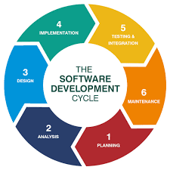

Figure 1: System Development Life Cycle

* **Planning and requirement analysis:** Based on the objective of the product, a project plan will be conducted. The product feasibility will be assessed according to economic resources and the technical requirements. The quality assurance requirements for the product will then be set. Risk assessment is also done in this stage to ensure the project proceeds with minimum risks.
* **Defining requirements:** Product requirements are to be defined and documented clearly in this stage. This is done through a Software Requirement Specification (SRS) document.
* **Designing the product architecture:** Base on the SRS document, a Design Document Specification (DDS) document is formed. It contains design proposals for the product architecture including the flow of data with external, and third-party modules if such modules are used. The document will then be reviewed by important stakeholders to decide on the best approach.
* **Developing the product:** This is the stage where the product is built. The programming code is generated according to the DDS document. The programming language is chosen depending on which type of software is being developed. Coding guidelines are defined by the developer’s organization.
* **Testing the product:** In this stage, the software is tested for defects. Product defects are reported, tracked and fixed. The testing phase is repeated until the product reaches the standards defined in the SRS.
* **Deployment and Maintenance:** After the product is carefully tested, it is ready to be deployed. The product is deployed according to the strategy of the organization. Maintenance is done after the product is released when new errors are discovered or

As mentioned earlier, there are many types of system development models, which are essentially based on the foundation of the System Development Life Cycle (SDLC). As such, we carried out a study on the two most used models of system development; the Waterfall Model, and the Prototyping Model - in order to find the most suitable system development methodology.

1. **Waterfall Model:**

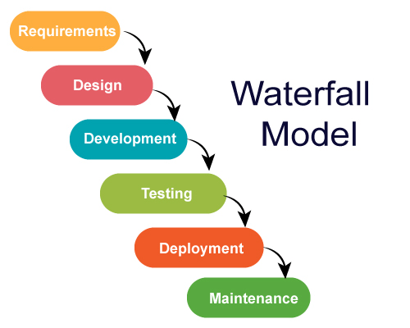Waterfall approach was the first SDLC Model to be used widely in Software Engineering to ensure success of the project. In "The Waterfall" approach, the whole process of software development is divided into separate phases. The uniqueness of this model is that developers have to complete a stage before they can proceed to the next stage and cannot return to the previous stage after proceeding to the next stage. The stages of the waterfall model are shown in figure below.

Figure 2: The Waterfall Model

*Figure SEQ Figure \* ARABIC 1: Overview of the Waterfall Model*

**Advantages and Disadvantages of Waterfall Model**

Table 1: Advantages and disadvantages of the Waterfall Model

|  |  |
| --- | --- |
| Advantages | Disadvantages |
| Easy to understand and implement; documentation is produced at each phase. A new team member can easily understand what’s to be done. | Real projects rarely follow sequential approaches. Not a good model for complex and object-oriented projects. |
| Reinforces good habits: define-before-design; the more disciplined approach | High amounts of risk and Uncertainty at the beginning of the development |
| Identifies deliverables and milestones; this model helps find problems earlier on, which can save a business a ton of money. | No working version of the system until very late. Poor model for long and on-going projects. |
| Works well on mature deliverables | You cannot go back a step; if the design phase has gone wrong, things can get very complicated in the implementation phase. |

1. **Prototyping Model**

Prototyping is defined as the process of developing a working replication of a product or system that has to be engineered. It offers a small scale facsimile of the end product and is used for obtaining customer feedback as described below:

*Figure SEQ Figure \* ARABIC 2: Overview of prototyping model*

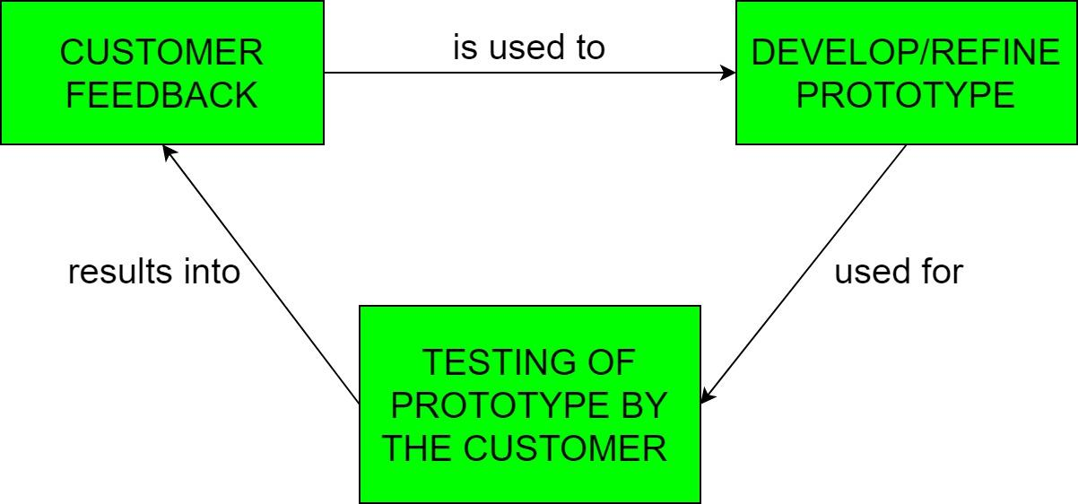

Figure 3: The Prototyping Model

**Advantages and disadvantages of Prototyping**

Table 2: Advantages and disadvantages of the Prototyping model

|  |  |
| --- | --- |
| **Advantages** | **Disadvantages** |
| The users get to see the partial product early in the life cycle. This ensures a greater level of customer satisfaction and comfort | Costly with respect to time as well as money |
| New requirements can easily be accommodated as there is scope for refinement | There may be too many variations in requirements each time the prototype is evaluated by the customer. |
| Missing functionalities can be easily figured out. | Poor documentation due to continuously changing customer requirements. |
| Errors can be detected much earlier thereby saving a lot of effort and cost, besides enhancing the quality of the software. | It is very difficult for developers to accommodate all the changes demanded by the customer. |

### III.1.1.2. Choice of System Development methodology

After thorough studies of the above proposed system development methodologies, we have arrived at the conclusion that **the** **Prototyping model of methodology** is best suited for the purpose of this project. Prototyping is a very good choice to demonstrate the technical feasibility of the product, which is one of the main objectives of this Farmer stakeholder connect platform (FaShCoP). The main reason of choosing prototyping is because the proposed system will require a lot of user interaction to collect enough user feedback, in order to be able to produce a reliable system that meets user expectations.

A FinTech platform like this one requires a lot of delicacy. Managing people’s money is never a trivial task, and so a system that has anything to do with the hard earned money of others is supposed to be meticulously developed and refined to ensure there are no potential loop holes. To ensure the robustness, reliability, and efficiency of our proposed application, several users have to use the software for meaningful periods of time so that all potential flaws and bugs can be identified and rectified. This is only possible with a prototype. Also, the successful implementation and validation of a reliable security system can only take place after rigorous testing by users. Once the prototype is accepted by target users, it will be deployed for use.

### III.1.2. Hardware and Software requirements

1. **Hardware Requirements**

* **Laptop/Personal Computer:** 64 bits processor, 2.53GHz CPU, 4 GB of RAM
* **Mobile Phone**: Any mobile with minimum specifications and access to the internet.
* **Internet Connection:** 3G/4G Modem, allows to run tests.
* **Server:** Gateway Windows/XP personal computer. The server is the existing computer used by the company to store the FaShCoP database.

1. **Software requirements**

The FaShCoP interfaces with several software components:

* + The Application will run on the web, accessible on mobile and personal computers. This is the application farmers and stakeholders will use to Connect to each other and stay in contact. We will be writing this application.
  + Apache Xammp: MySQL database which runs on the Server.
* Active Sync which runs on the Server.
* Visual Studio Code editor (Freeware)
* React JS – JavaScript framework for front-end development
* Laravel – PhP Framework for backend development

1. **Development:**

**Front-end**

* **HTML**
* **CSS**
* **JavaScript**
* **React JS**

**Back-end**

* **PhP**
* **MySQL**
* **Laravel**

1. **Deployment**

* **Local host: PhP MyAdmin**
* **Github**

1. **Functional Requirements**

FaShCoP will automate the Process of connecting farmers and stakeholders by;

* FR-1(R): The system will allow users to register and create, and complete their profiles; as farmers, investors, companies, NGOs, Government Institutions, cooperatives, trainers, technicians.
* User authentication with emails, phone numbers.
* FR0(R): The system will allow the users to lookup projects based on specified location, sector, interests and preferences. This information will include project names, details, description, objectives, business plan, pictures, videos and other supporting evidences.
* FR1(R): The system will allow automatically generate reports/summary of projects based on results from well-structured project forms filled by users. - R2(R): The system will automatically recommend registered projects to stakeholder users based on set criteria.
* FR3(R): The system will allow the stakeholders to reach out to the farmers through personal or group chats; including emails and other mailing platforms.
* FR4(R): The system will allow users to schedule meetings.
* FR5 (D): The system will allow users to advertise and market their products and ideas.
* FR6(R): All users can interconnect with each other, via chat forums.
* FR7(R): The system allows users to find training, seminars, and mentors.

**III.2. Project Specification and design**

### III.2.1. Choosing a modelling Language:

Every software system must first be modelled before it is implemented. Modelling techniques or languages like MERISE, LCS, SADT, UP and UML are under consideration. These methods are often used in educational and industrial systems. Each of these methods has its own advantages and disadvantages. For our farmer stakeholder connect application, we will use the **Unified Modelling Language (UML)** to model our system before implementation.

III.2.2 Justification for the choice of modeling language – UML**:**

UML is the industry standard for software design. In other words, it’s the only software design notation that one can expect peers to be familiar with. The software architecture is the blueprint for the system; it allows reasoning about performance, availability, security, and other attributes. Allows planning for incremental development, and guides work assignments and tracking. However, even the best architecture, created based on years of experience and carefully selected design patterns, may be useless if not properly communicated to the people who need to use it.

**Modeling with UML** consist of six **stages Pre-Analysis, Analysis, System Design, Implementation and Test and Reengineering**. The detailed study analysis is based on an abstraction cycle, which aims to design an information system by following a modelling logic consisting of three levels:

* Conceptual: what are we trying to do?
* Logical/Organizational: who, when and how?
* Physical: what means and constraints.

### III.2.3. Description of the System

The Farmer stakeholder connect platform project is initiated to create the possibility for small or big farmers with good farm ideas (gardening, animal rearing, horticulture etc… ) to register and expose their projects to potential investors and other agricultural stakeholders, in order to pull investment and indispensable technical support.

Farmers will be able to register their projects from home, adding all the necessary details about the projects and themselves, including images, videos and formal or non-formal project documentation. These projects are intelligently recommended to Stakeholders based on their preferences, in a well-designed feed. Stakeholders can also search for and find out about various farm projects in several places across the country. Specific functionality that the system should have includes:

* User Registration as farmers, investors, NGOs, Government institutions…
* Farmers register projects by filling out project forms; providing details of the projects, contact details, picture, video or documented evidence and all forms of authenticity.
* A feed for both farmers and stakeholders; farmers are suggested related projects of other farmers with whom they can collaborate, while stakeholders are recommended the most ideal projects based on their preferences and interests, as specified in the registration.
* An advanced Search for registered projects in a particular domain/sector or location or with a specific objective or size.
* Connecting individual farmers and stakeholders, through chat forum or contact details.
* Customized display of locations of nearby farmers on Google map.
* Scheduling meetings, automatically generating zoom links, providing reminders.
* Customized Chat forums for all users.

## III.3. Implementation

### III.3.1 Class diagram

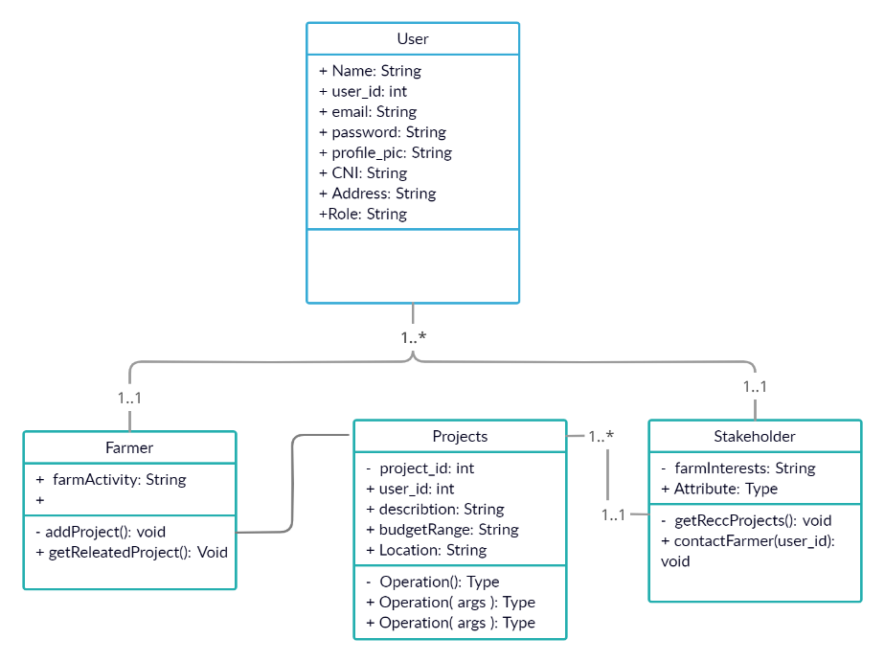The Figure below show the class diagram model of the facial recognition.

Figure 4: Class diagram FaShCoP

### III.3.2 Activity Diagram

Register/Login as Farmer or Investor

Set up User profile

Access Feed – Available Farm projects (Recommended, Top, All)

Yest

No

Is Farmer?

Add project to wish list

Submit Project

Contact farmer

Connect with other farmers

Contact farmer

Figure 5: Activity Diagram

### III.3.4. Use Case diagram (UML) of FaShCoP

Government Institution

Service

Authentication

Agro Technician

Private

Investor

Farmer

**FaShCoP**

NGO

Farmer Cooperative

# CHAPTER 4: RESULTS AND DISCUSSION

## IV.1 Summary of Results

This chapter is concerned with the output of our prototype testing. The design of our system took place in two phases. First we designed the User Interfaces (UI/UX) with the Figma technology. And then we hacked together a responsive web application using the React JS Framework, hosted on a Github repository. The Performance of this system depends on the ease with which a farmer (even a less educated one) can register/create an account on the platform. Performance also depends on how quickly and effectively, submitted projects can be recommended to registered investors.

### IV.1.1. Testing

Testing is the process of verifying that the program is working as intended. In this stage, each feature is checked for defects. Product defects are reported and fixed by us. The testing phase is repeated until the product reaches the standards defined in previous stages. In this project, Testing is done in two stages: Unit testing during development and after deployment to the server. The most common scenarios are slow internet connection, abnormal user inputs and rapid intakes of user input. We follow each scenario to check if the feature is producing the expected outcome. Unit testing will be automated for new features after the core functionalities have been completed. Testers include every member in our development team, who can test this feature live on the development server. As the server has its own dedicated database, modification to the content here does not affect the web application’s content. When any errors or performance issues occur, it will be reported.

### IV.1.2 Project Assessment

This section provides an assessment on the result of the project based on the defined requirements mentioned in the project objectives.

1. **Functionalities**
2. **Landing Page**

* Users do not need an account to access FaShCoP’s landing page.
* Landing page comprises a Carousel with sample agricultural project images, a description of the platform.

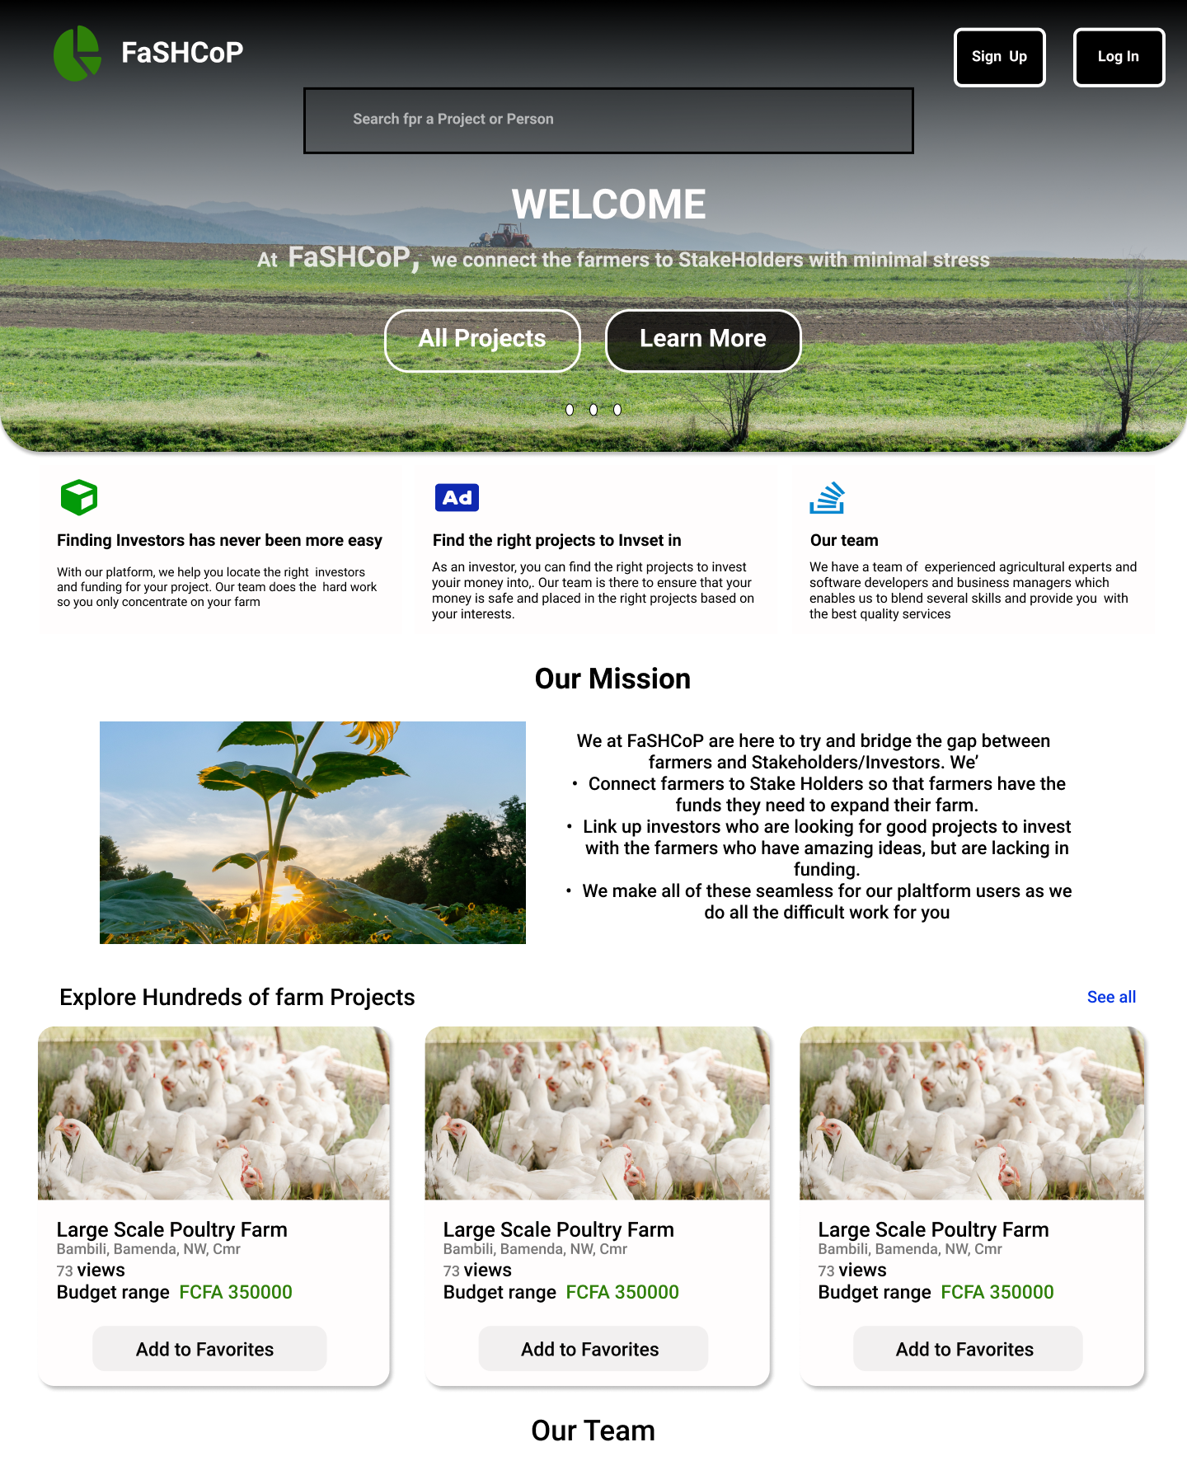

1. **Authentication**

The authentication section has achieved all the requirements mentioned.

* Users are required to have to account to be issued access to a content feed (landing page after signup/login), and a profile section.
* Signup forms must have the following fields: Role (farmer or investor), Username, Password, Email, and Full name, Date of birth, Gender, Profile picture, Location, profession, Agricultural interests (for investors), agro-activity (for farmers). The location section must have a search with auto completion.
* As seen earlier, access to certain functionality is limited to certain users.

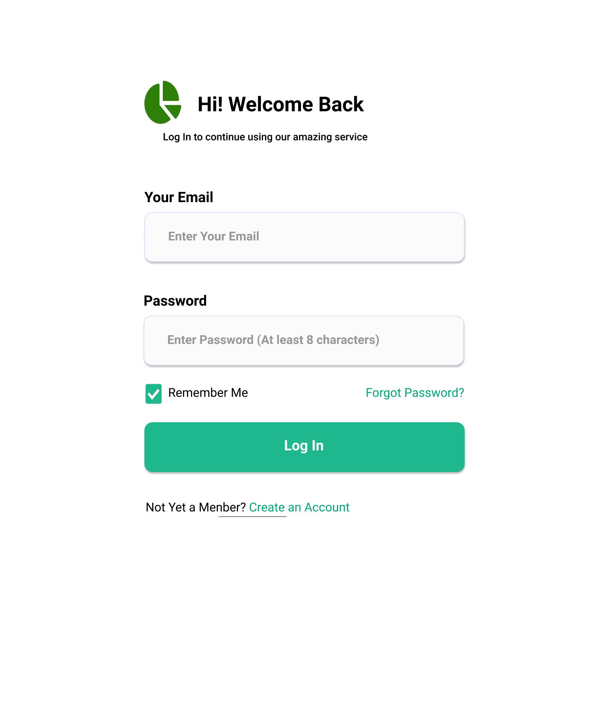

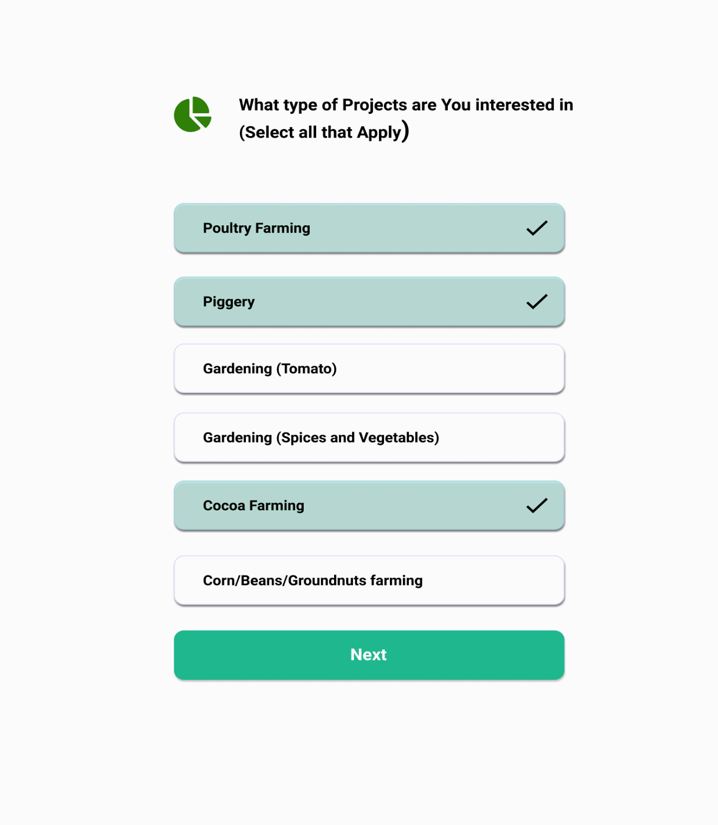

1. **User Feed**

The user Feeds for both farmers and investors has achieved the predefined requirements, except for the “add to wish list button on each project”. These include a content display of;

* Recommended projects (Strictly for investors), based on the specified interests for investors.
* Similar projects (only for farmers), based on their specified agro-activities, or already submitted projects.
* Top projects submitted (based on the number of clicks on the project link).
* All projects submitted (for both farmers and investors).
* Project content display contains the following;
* A thumbnail of the project (jpg, png, jpeg)
* A brief description of the project
* Farmer info (Name, Address, contact)
* A “wish list” button (still under development)

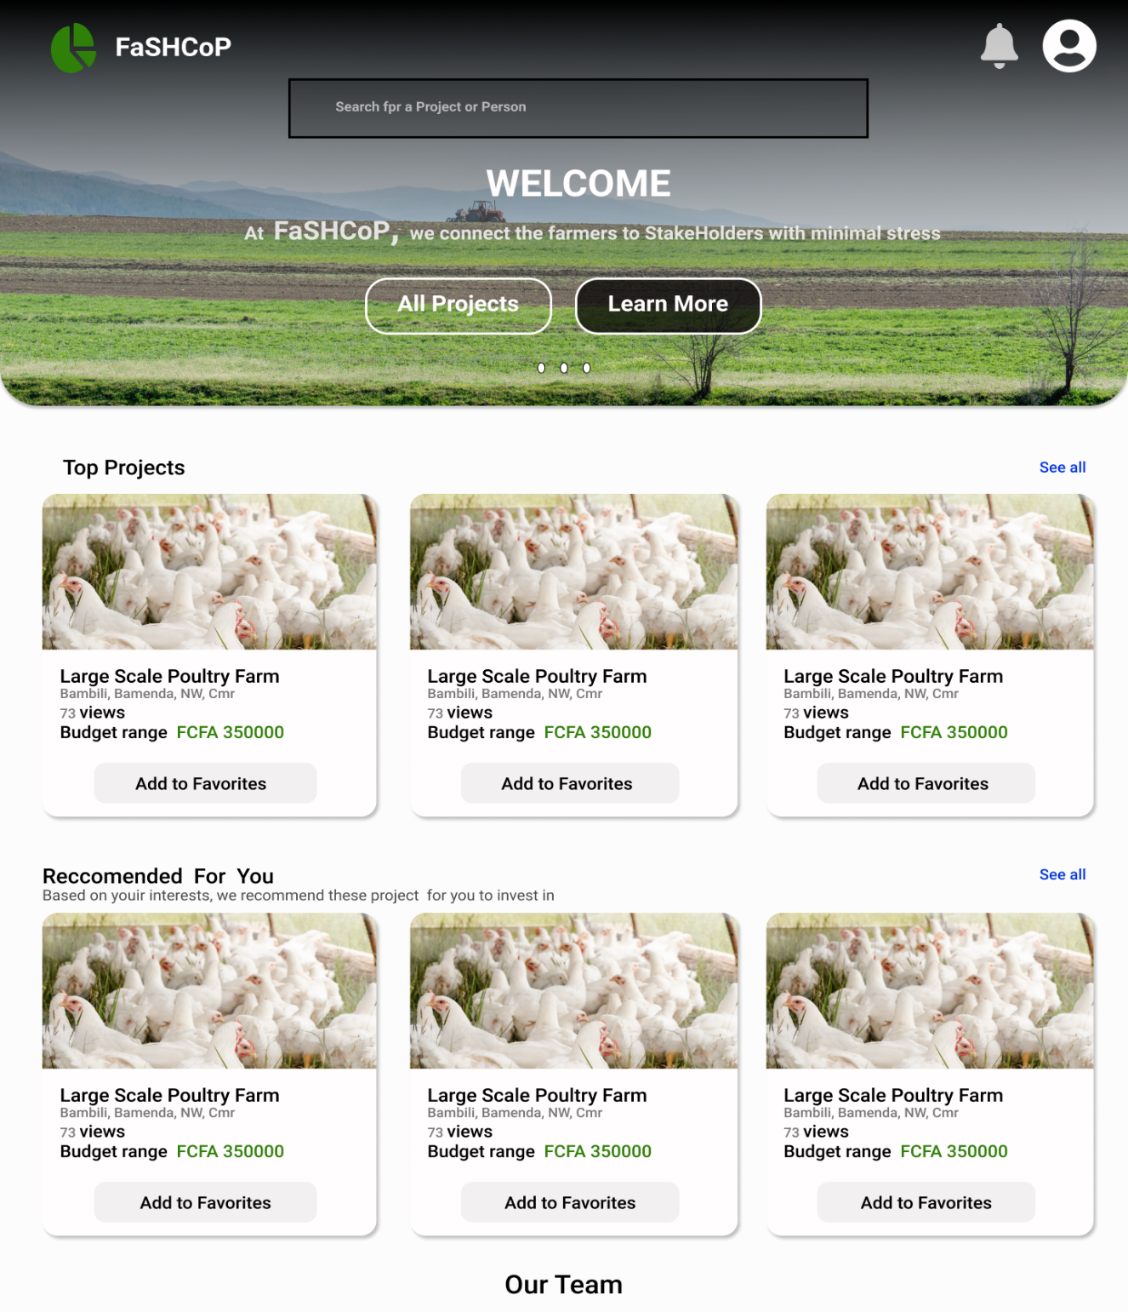

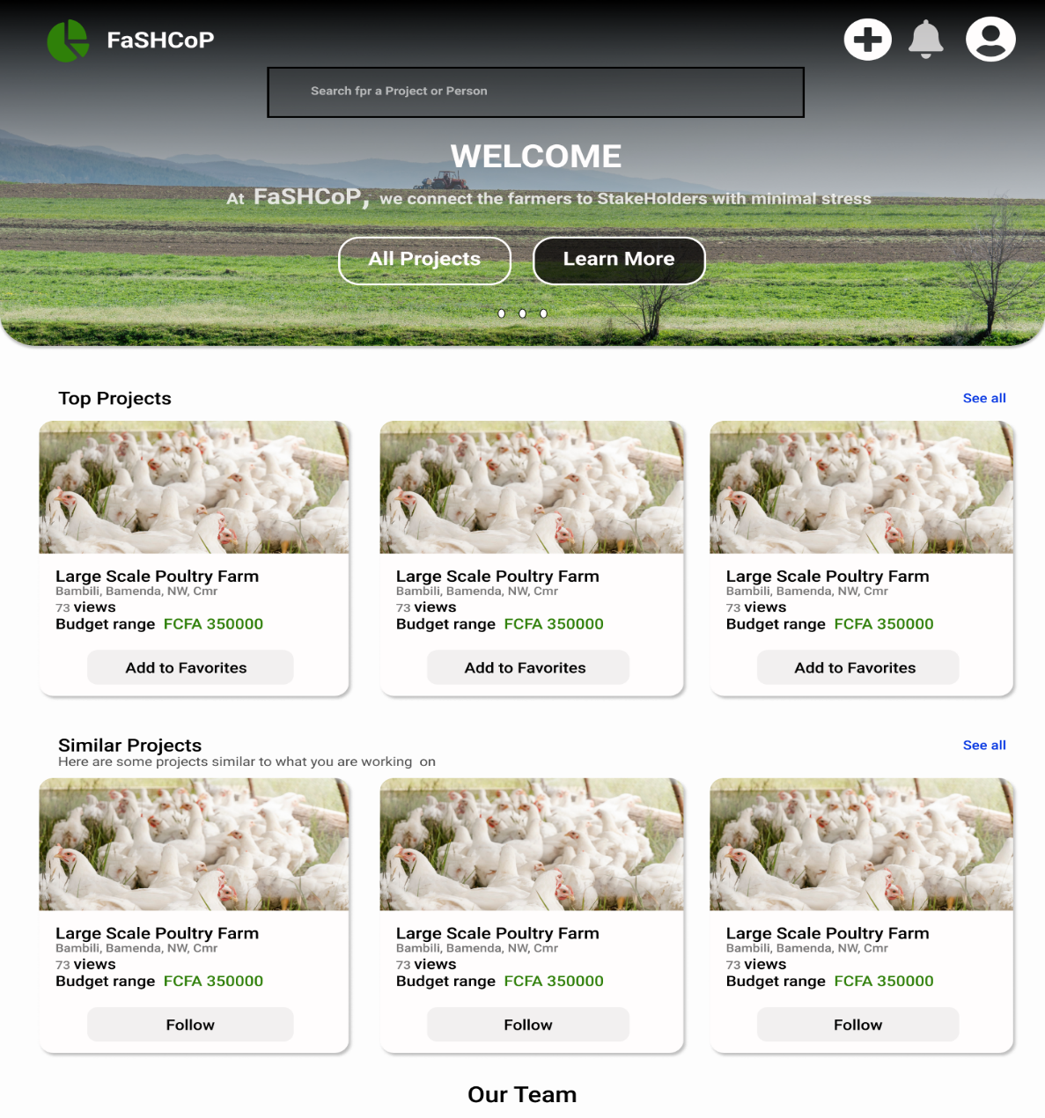

1. **Add/Register/submit Project section**

The add/submit/register project section for farmers is also successfully implemented. Farmers can register and submit their projects by filling simple forms, displayed using the same UI and filters as on the Create User page.

The Submit project button can be found on the farmer’s dashboard, just above their feed, and also on the profile section. With each project, a delete option is provided. All deletions need to be confirmed and are permanent.

Project Submission is done by filling a form, which comprises of;

* The Project description (Detail and summary).
* Location of project.
* Specific agricultural sector and activity (gardening – Tomato farm).
* Project requirements/needs/resources.
* Scale/Budget range (minimum and maximum possible investment required).
* Estimated Profit margin.
* Images of the proposed project (land, past successful projects, etc.)
* A pdf project document (Optional).
* Videos of the proposed project (Optional).

The Location, sector/activity, and scale of the project will be used to match the project with target investors, and recommended to them on their respective content feeds.

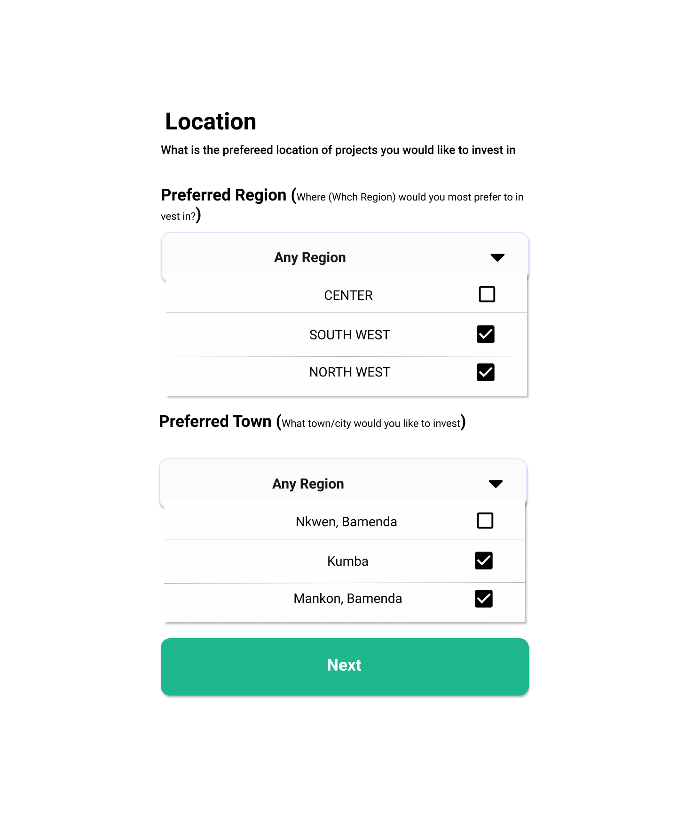

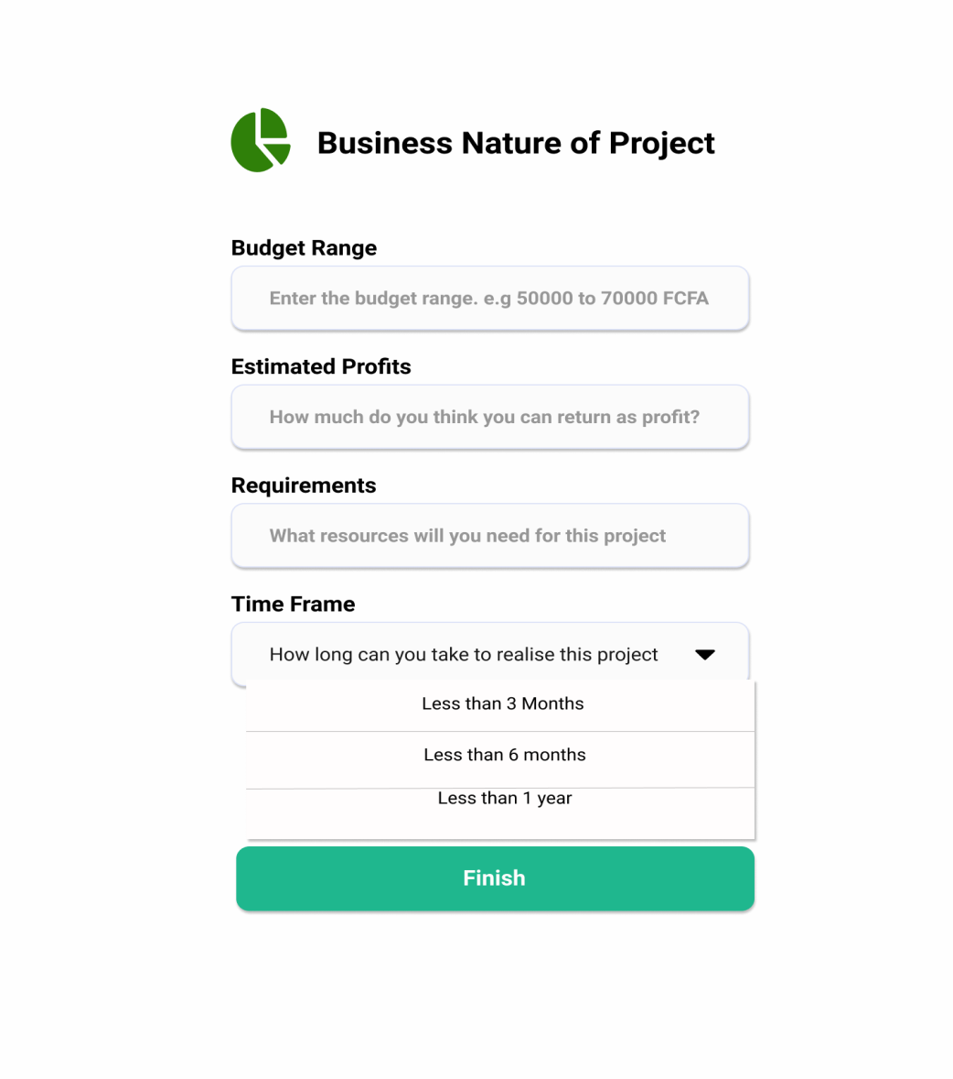

1. **User Profile**

In addition to adding intriguing projects to a wish list, investors can also view farmer profiles, to assess their credibility for themselves. The farmer profile contains;

* His/her personal and professional info, including a profile picture.
* Professional experience,
* Previously submitted/completed projects.

The Investor’s profile section also contains;

* Personal info including a profile picture,
* Professional experience,
* Wish listed projects,
* Farmers previously contacted.

1. **Contact Farmers**

Investors can contact farmers by customized email, auto generated by the system. Farmers also receive an automated email once their project has been wish listed by an investor.

**IV.2. Evaluation of Results**

Based on the various performance and functionality tests carried out, we can say that the quality requirements of this farmer stakeholder connect system has been achieved. Quality check was done with each new implementation. FaShCoP has achieved the following quality requirements:

* The system has an uncluttered, simple user interface with readable font and font-size. UI related requirements are reviewed by testers and changes are taken into consideration by our team.
* It is responsive on both the web browser and the mobile browsers. A dedicated Sass file was created for mobile view and three different viewports. In smaller view ports, the navigation bar is collapsed, items are displayed in one column, font sizes and button sizes are decreased accordingly.
* Farmers (even the less educated) can easily create accounts, update their profile information, access their content feeds, and submit projects.
* Investors can also easily create accounts, update their profiles, access content feeds, add projects to wish lists, view farmer personal info, and contact farmers.
* Loading indicators have been added for asynchronous items. Asynchronous items are attached with the isFetchingData() method which only resolves when the request is completed. Loading indicators are attached to each of these items.
* There is no shuttering while scrolling and the loading speed of each view are reduced to a minimum. The system must not cause any crash or freezes to the browser. The React JS framework greatly reduces the loading time for each section as it only loads the parts that have been modified. Webpack also bundles modules into a minified file which improves performance. In addition, all unused event handlers are cleared preventing memory leaks that can cause browser freezes or crashes.

CHAPTER 5: GENERAL CONCLUSION

## V.1 Reflection

In this report, a web based farmer stakeholder connect platform is presented. A platform which is proposed to significantly resolve a major problem of agriculture in Cameroon;

* + - 1. The financing problems facing Cameroonian farmers, who generally find extreme difficulties getting loans from banks,
      2. The paradox where private individuals, NGOs who have access to this loans (investors), cannot find the right places to invest their money in exchange for fruitful returns.

The project was a success. The application achieved all the predefined functions and quality requirements. First we designed a fully working and responsive landing page presenting the project to the world. Then we designed a working dashboard for all users, with a content feed, profile section and a submit project section for farmers. Our system intelligently recommends projects to investors, based on their specified interests and Location. This is very important for a platform like this, where target audience is very important. However, investors still have access to all the other projects and even the Top projects gaining attraction from many other investors. Farmers can also conveniently and easily submit their projects and all relevant documentation to go along.

With each implementation, there was considerable effort to enhance extensibility. As a result, the product has high maintainability, modifiability, and scalability. Maintenance will be done in the upcoming future and is outside of the scope of this paper. While the final project result is satisfactory, there were still many aspects that can be optimized. There is always potential for improvements in code structure, functional logic, and user experience design and application performance. I will continue to do code refactoring to improve readability, maintainability and reduce complexity.

The main objective of our project was to design a platform that will allow farmers even with limited educational backgrounds, to register and expose their brilliant farm ideas/projects to potential investors from within and outside of Cameroon. On our platform, these projects are intelligently recommended to registered investors, who can reach out to the farmers in several ways, including by automated emails from the platform. It was essential to have an easy-to-use platform, very accessible to every individual. We also aimed to make this platform web based, in order to allow maximum possible access on mobile and desktop devices; and also to ensure that even farmers with low Internet bandwidths can still benefit from the technology.

## V.2. Recommendation for Future Development

A platform which connects farmers to investors is essential to helping farmers find financing for their projects, and also help investors put their monies into the right places. However, such a platform cannot be limited to simply putting farmer and investor together. A referee is required, to ensure that investors actually put their monies into credible farmers, who really deserve the funding. Investors should also not have to worry about all the technical financial details.

This is what can be achieved with a FinTech platform like that which has been developed in the course of this report. Nevertheless, a trustworthy and credible system is difficult to develop in Cameroon, considering the high rates of Internet scams. As such, we have the following recommendations which we believe will go a long way;

* We the researchers recommend that all potential users, both learned or less educated, should be given appropriate training on how to use the application.
* A comprehensive user documentation, user guide or user manual is required to serve as a resort for users, in case of any confusion in use of the application.
* The human identity of users should be better verified. To this regard, we recommend implementing a manual ID card verification system for all users. This will help to eliminate fake or duplicate users from the platform.
* Once a projects starts to get some traction, we recommend setting up a team that will pay visits to these farms, scout the fields to verify the legitimacy of submitted project, ensure that the farmer is worthy of investment. Once this is done, a “verified” feature can be added to the platform, confirming the credibility of the said farmer.
* We also recommend partnering with farmer cooperatives, credit unions and/or other microfinance institutions, to help collect, store and manage the funds from investors. This is to make life extremely easy for the investor. All they have to do is point to a specific microfinance, a current account is created and credited with their investment. Benefitting farmers can then reach these set microfinances for day to day farm transaction.

# References

(2013). *Connecting Africa An Assessment of Progress Towards the Connect Africa Summit Goals.* Kigali: AfDB.

*Digital learning*. (2019, September 25). Retrieved from Victoria State Government.

BEDUSHE, I. O.-B.-C. (2020). *INTERNSHIP ON WEB-BASED E-COMMERCE APPLICATIONDEVELOPMENT AT BANGLA SOFT COMPUTER USING REACT J.* Dhaka, Bangladesh: UNIVERSITY OF LIBERAL ARTS BANGLADESH.

Beechy, G. ( 2014). Crowdfunding- Alternative financing for Africa. *Available at: http://www.kwm.com/en/uk/knowledge/insights/crowdfunding-alternative-financing-for-africa-20140723*.

Christensen. (2021, February 17). *Web Application Definition.* Retrieved from https://techterms.com.

FLORES, H. M. (2017). Connecting farmers and investors in the Philippines. *Impact Journalism Day*, 2.

Gough, K. L. (2013). *Youth employment in a globalising world. .* FAO: Rome: International Development Planning review.

KANYANGOGA, J. B. (2020). *CHALLENGES FACED BY THE FARMERS AND.* Kigala, Rwanda: Panafrican farmers' organization.

Khuat, T. (2018). *Developing a frontend application using ReactJS and Redux.* Leppävaara: Laurea University of Applied Sciences.

Mansini, C. M. (September 2018). *THE USE OF FINANCIAL TECHNOLOGY.* ADBI Working Paper Series.

McIntosh, C., & Mansini, C. S. (2018). *The use of financial technology in the agriculture.* Asian Development Bank Institute (ADBI), Tokyo.

Muhammad Anshari*, M. N. (2018). Digital Marketplace and FinTech to Support Agriculture. *EnergyProcedia*, 1,236,235.

Nikola M. Trendov, S. V. (2019). DIGITAL TECHNOLOGIES. *Food and Agriculture Organization of the United Nations*, 50-62.

R., D. R. (2019). CROWD FUNDING IN AGRICULTURE. *KERALA KARSHAKAN*.

Sullivan, F. &. (2015). Sub-Saharan Africa to Witness Fastest Growth in Mobile Usage Rates Globally. *http://ww2.frost.com/news/press-releases/sub-saharan-africa-witness-fastest-growth-mobile-usage-ratesglobally-finds-frost-sullivan*.

Velde, B. a. ( 2018). *Skill needs for the future. Pathways for Prosperity Commission Background.* Oxford, United Kingdom.

Vergara, R. A. (2018). *Crowdfunding platform contributions to campaign success: A two-case study of Philippine-based platforms.* Phillipine Academy of Management E-Journal.

Yasmine Bahri-Domon. (2020). Crowfunding. *Business in Cameroon*, 3-10.

Zainuddin, Z. (2018). Crowdfunding: Threat or Opportunity?